ARDUINO BASED HOME AUTOMATION USING BLUETOOTH

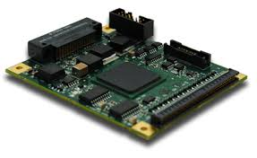 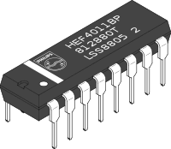

**INTRODUCTION:**

We are living in the age of technology, life of this era is now becoming shorter and easier. Many things in the past which was done manually are now perform by machines. The field of electronics is making our lives much more comfortable.

This Aurduino based home automation using Bluetooth project facilitates the user to turn on and off electrical devices. The major advantage of this project is the saving of time.

**OBJECTIVE:**

Basically the main idea of the project is to make a general remote of electrical devices such that its cost shall be low and saves the user time.

The hardware and the software which we have used in our project is mention below.

**HARDWARE:**

* Arduino UNO
* Microcontroller
* Relay board
* Bluetooth module
* Breadboard
* Jumper wires

**SOFTWARE:**

* Arduino 1.6.9 compiler
* Proteus 7
* Android application

**DESCRIPTION OF HARDWARE:**

* **ARDUINO UNO:**

It is a platform which links software with hardware by making easy for

The user.

* **MICROCONTROLLER:**

A microcontroller is same as like a computer on a single chip. Its function is to control and incorporates the microprocessor.

* **RELAY BOARD:**

It is an electrical switch use to handle the high power required directly to control an electrical device.

* **BLUETOOTH MODULE:**

It is a hardware component which gives a wireless product to operate with the computer.

* **BREADBOARD:**

A breadboard is a simple dotted board on which circuits are check so that they can be soldered on board.

* **JUMPER WIRES:**

It is a single wire use to make connection usually on breadboard.

**DESIGNING OF PROJECT:**

The projects has two main parts; the hardware components and the software program. The microcontroller plays the main role between the two. It receives the message from the software and then command the hardware. The relay board attached sounds the on and off of the switch.

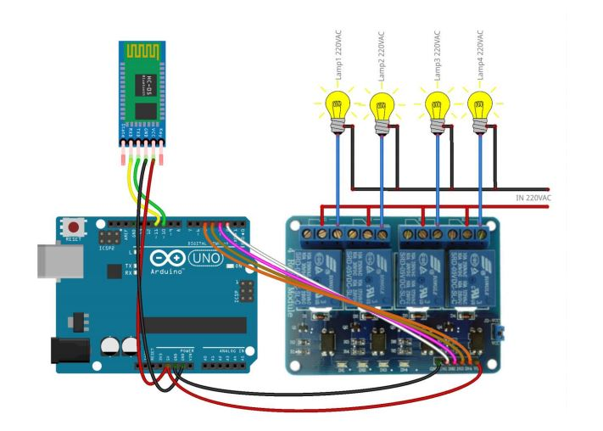

**WORKING:**

Arduino based home automation is a helpful tool for the people to control electronic devices just by using their mobile phone. The user by using an android application on his mobile phone sends command to the arduino like in this project by Bluetooth, the arduino is connected to PCB which have 4 to 5 relays. Now if the user click on for device 1 the 1st relay on the device which the user had saved in program and similarly for the rest devices.

**ARDUINO CODE:**

***It is compiled on Arduino IDE 1.8.8.***

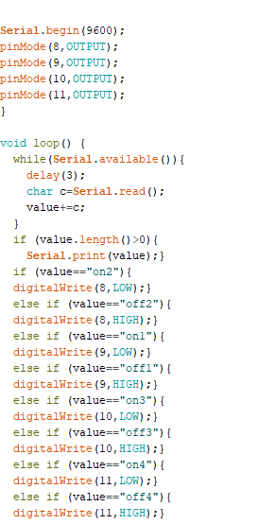



**CONCLUSION:**

The home automation devices are now taking the world into a new era. No matter what is the device it is now control by our mobile. In this project we only check the LED but this project can be used for many other devices also.